1. Which are the top three variables in your model which contribute most towards the probability of a lead getting converted?

Solution:

Based on the coefficient values from below screenshot, the following are the top three variables that contribute most towards the probability of a lead getting converted :

* Lead Source_Welingak Website
* Lead Source_Reference
* What is your current occupation_Working Professional

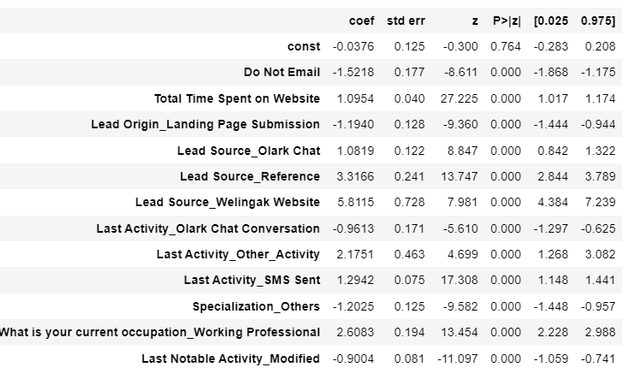

1. What are the top 3 categorical/dummy variables in the model which should be focused the most on in order to increase the probability of lead conversion?

Solution:

Again, based on the coefficient values from the screen shot in the question above, the following are the top three categorical/dummy variables that should be focused the most in order to increase the probability of lead conversion :

* Lead Source_Welingak Website
* Lead Source_Reference
* What is your current occupation_Working Professional

1. X Education has a period of 2 months every year during which they hire some interns. The sales team, in particular, has around 10 interns allotted to them. So during this phase, they wish to make the lead conversion more aggressive. So they want almost all of the potential leads (i.e. the customers who have been predicted as 1 by the model) to be converted and hence, want to make phone calls to as much of such people as possible. Suggest a good strategy they should employ at this stage.

Solution:

* Comparing the values obtained for Train & Test: Train Data: Accuracy : 81.0 % Sensitivity : 81.7 % Specificity : 80.6 % Test Data: Accuracy : 80.4 % Sensitivity : 80.4 % Specificity : 80.5 % Thus we have achieved our goal of getting a ballpark of the target lead conversion rate to be around 80% . The Model seems to predict the Conversion Rate very well and we should be able to give the CEO confidence in making good calls based on this model to get a higher lead conversion rate of 80%.
* Finding out the leads which should be contacted: The customers which should be contacted are the customers whose "Lead Score" is equal to or greater than 85. They can be termed as 'Hot Leads'.

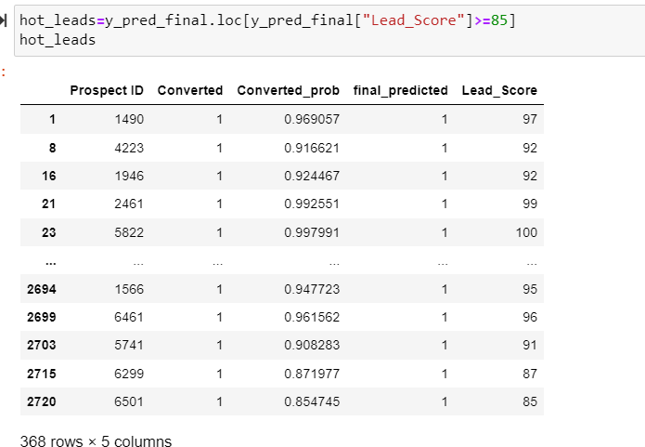

1. Similarly, at times, the company reaches its target for a quarter before the deadline. During this time, the company wants the sales team to focus on some new work as well. So during this time, the company’s aim is to not make phone calls unless it’s extremely necessary, i.e. they want to minimize the rate of useless phone calls. Suggest a strategy they should employ at this stage.

Solution:

In order to minimize the rate of useless phone calls, the company may contact all the leads which have a conversion probabilty (value = 1) . However, the flipside here would be that, we may miss out on those leads that are actually converted but then the model wrongly predicted them as not converted. This should not be a major cause for concern as the target has already be achieved.

